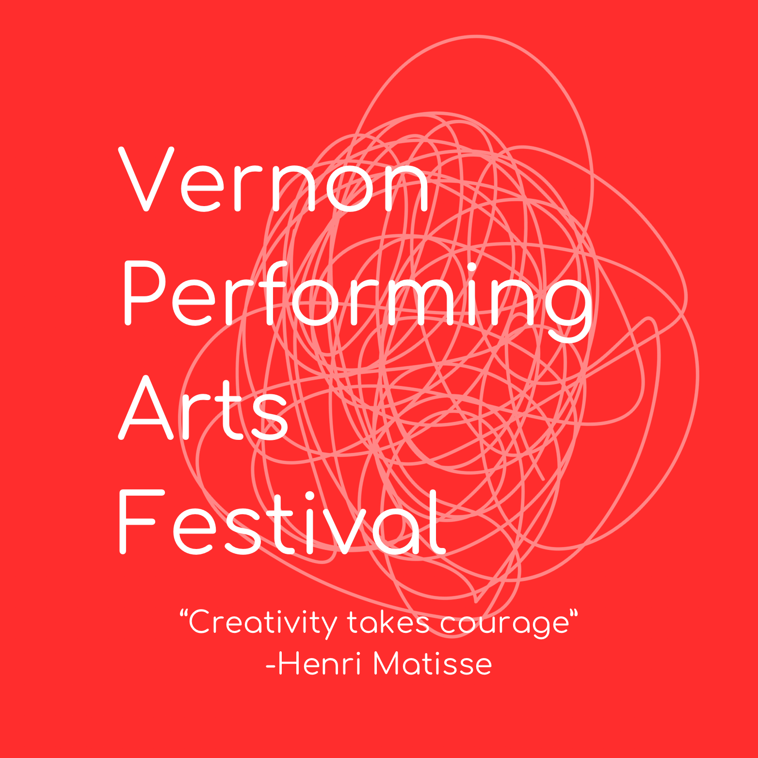

Dance Syllabus
Updated November 5th 2025

Contents

- Festival Information
- General Rules and Information
- Eligibility
- Entry Information
- Ages, Fees and Time Limits
- Categories and Classes
- Provincials
- Workshops
- Scholarships and Awards
- Etiquette

Festival Information
FESTIVAL DATES
Dance: February 28 - March 6 2026
Gala: April 4th, 2026
FESTIVAL VENUE
Dance: Vernon Performing Arts Centre, 3800 33rd St, Vernon
Gala: Vernon Performing Arts Centre, 3800 33rd St, Vernon
REGISTRATION
Opens: November 15th, 2025
Closes: January 15th, 2026

GENERAL RULES AND INFORMATION
Teachers, participants and parents are responsible to familiarise themselves with the syllabus and rules before registering. Failure to comply with the general rules will result in disqualification. In case of disqualification, fees will not be refunded.

ELIGIBILITY
- Festival Committee
All matters not covered here will be decided by the Festival Committee. All decisions are final.
- Eligibility
Competitors must reside in the Interior or Northern BC (east of Chilliwack) or the Okanogan District of Washington State. Participants from other areas may perform for adjudication only (not eligible for awards or Provincials).
- Amateur Status
All classes are for amateurs unless stated otherwise. An amateur is someone whose main income is not from music or dance. Students who teach to support their education are eligible.
- Group Membership
Choir, band, and orchestra competitors must be active members of their organizations.
- Age Verification
Age is as of December 31 before the Festival year. Parent, guardian, or teacher signature required on age-restricted entries.
- Entries
Competitors may not enter more than one performance in the same class (except Piano Preparatory A & B). The same piece cannot be performed in multiple classes.
- Repeat Performances
Winning pieces performed again within five years will receive adjudication only.
- Venue Use
Festival performance spaces may not be used for practice during the event. Violations may result in disqualification.
- Class Changes
Classes may be divided or combined at the discretion of the Festival Committee.
- Time Limits & Syllabus
Time limits must be observed. Refer to each discipline’s syllabus for specific rules.
- Advertising
All commercial displays or promotions must be pre-approved by the Festival Committee.
ENTRY INFORMATION
How to Enter
Registration Opens: November 15th, 2025
Registration Closes: January 15, 2026
All entries must be submitted online.
Payments may be made via PayPal or by cheque mailed to the Vernon Performing Arts Festival.
All entry fees are due within 7 days of registration closing.
- Confirmation: Competitors will receive an email confirming their entry, class date(s), and location once registration is complete.
- Committee Discretion: The Festival Committee reserves the right to refuse any entry. If this occurs, fees will be refunded in full.
- Eligibility: Teachers and competitors are responsible for ensuring all entries meet eligibility and class requirements. Acceptance of an entry does not guarantee eligibility. The Festival is not responsible for errors or incorrect entries in the official program.
- Withdrawals: Entry fees are non-refundable. Medical emergencies will be reviewed on a case-by-case basis.
- Changes: Once the official Festival Program is published, schedule changes cannot be made. Category change requests may be submitted to the Festival Committee 7 days prior to the start of the festival with a $15 fee, payable prior to performance.
- It is the responsibility of competitors and teachers to follow the Rules and Regulations of the Festival.

MUSIC, PROPS, STAGE & LIGHTING

- All music must be uploaded to the designated Dropbox folder and will be played by Festival backstage staff.
- Music files must be submitted no later than 7 days prior to the start of the competition.
- Stage will be marked for centre and quarter points. No other markings are permitted.
- We regret that special lighting is not possible.
- Marley floor will be provided.
- Prop setup must be completed within 30 seconds and may be placed by the teacher or a Festival volunteer.
- Props must be lifted and placed, not dragged, to protect the Marley flooring.
- Exception: For Production numbers, all setup and takedown must be completed within the 15-minute performance time limit.

PERFORMANCE PROCEDURES

- Any dancer who leaves the stage during a performance shall be allowed one re-start for adjudication only. If the competitor is not at fault, i.e., failure of lighting, etc., the repeat performance will be adjudicated and marked as usual.
- Props may be placed by teacher or volunteer. Please do not drag or push items along the floor. Loading dock is available for large items during non-competitive times. Please coordinate with a dance venue volunteer if using the loading dock.

Ages, Fees and Limites

DANCE ENTRY FEES & TIME LIMITS
Solo | $25 | 3 minutes
Workshops | $25 | 1 Hour
Workshops : Late Registration | $30 | I Hour
Junior Choreography | $25 | 3 minutes
Improvisation | $15 | 1.5 minutes
Duet & Trio | $15 per person | 3 minutes
Groups (4+) | $12 per person | 5 minutes
Production | $12 per person | 15 minutes (includes set up)

- Age categories (determined by age as of December 31, 2025) will be automatically grouped as follows, and may be divided further, based on numbers:
  - 6 yrs and under
  - 8 yrs and under
  - 10 yrs and under
  - 12 yrs and under
  - 14 yrs and under
  - 15 yrs
  - 16 and over
- Duos, Trios and Group class age categories are determined by adding ages of all dancers together and dividing by the number of dancers in the group.
- Group categories by size:
  - Small: 4-8 dancers
  - Large: 9-15 dancers
  - Extra Large: 16 or more dancers

COMPETITIVE CLASSES | NON-COMPETITIVE CLASSES
All competitors will be given an adjudication and a mark for each performance and will be eligible for appropriate certificates, cups and/or scholarships | All presenters will be given an adjudication only

Categories and Classes
Ballet

Demi-Pointe Classical | Classical ballet based on any method (Cecchetti, R.A.D., Vaganova, etc.). Soft ballet shoes required. One hand-held prop allowed. Classical music with lyrics permitted (note: Provincials do not allow lyrics).
Pointe Classical | Same as Demi-Pointe Classical but performed on pointe. One hand-held prop allowed.
Contemporary Ballet | Combines classical ballet with freer, innovative movements such as floor work and turned-in legs. Focus on expression and artistry
Interpretive Ballet | Ballet technique used to express a mood or idea without telling a story. No sets or props permitted
Demi-Character | Ballet technique from the waist down, character portrayal from the waist up. Props allowed if integral to the dance
National Character | Folk or traditional dance representing a specific country. May use mime, props, and vocal/instrumental music. Character shoes permitted.
Improvisation | Open to soloists of all ages. 10-second preview, then 1-minute improvisation. Multiple dancers may share the stage depending on entries

Modern

Modern | Technique rooted in Graham, Limon, Horton, etc. Emphasizes contraction/release, fall/recovery, breath, and natural rhythm. Movement may or may not relate to music
Contemporary | Free movement combining multiple techniques (Forsythe, McGregor, Khan, Naharin, etc.). Emphasizes full-body engagement and exploration of human concepts.
Interpretive Modern | Uses modern or contemporary vocabulary to convey story, feeling, or emotional state. Movement reflects the intent of the music.

Stage

Tap | Focus on rhythmic clarity and shading of sound. No dubbed tap sounds. Coordinated arm and body movement.
Jazz | Energetic, rhythmic style using isolations, syncopation, and popular music. Up to 3 acrobatic tricks. No lip-syncing
Lyrical | Expressive dance interpreting slower music through soft jazz technique and emotion.
Street/Hip Hop | Emphasizes individuality and personal style. May include popping, locking, gliding, house, or power moves. Costumes and lyrics must be age-appropriate
Acro | Combines 50% dance and 50% acro elements. A simple, integral prop (not a mat) allowed.
Song & Dance | Equal emphasis on singing, dancing, and acting. No recorded vocals. Solos: 4 min max Groups: 6 min max.
Musical Theater | Dance adapted from film or stage musicals. Lip-syncing allowed. Judged on dance and characterization.
Variety | Character-based choreography blending multiple genres. This category does not include broadway songs or characters. Lip-sync permitted.

Dancers qualifying for provincials with jazz and jazz lyrical MUST choose a 2nd solo from tap, song & Dance, Musical Theatre, Hip Hop or Acro
Junior Choreography
Junior Choreography | Open to student choreographers registered in Ballet, Modern, or Stage. May be solo, duo, or group (solo fee applies). Dancer may perform in own work. Adjudicated on choreography, creativity, and performance.
Choreography Notes | One copy must be submitted to the Lobby Desk before the first session of the day. Include:  • Inspiration  • Costume & music choices  • Movement outline (counts for one section minimum).

Provincials
Provincial Representative Eligibility — Dance Disciplines
Each regional festival may send one representative per age group in each discipline to the B.C. Provincial Festival.
Age is determined as of December 31 prior to the upcoming Provincial Festival.
Age Division

Junior | 10-12 Years
Intermediate | 15 Years and under
Senior | 18 Years and under
Provincial Excellence | 20 Years and under

Discipline Requirements

Ballet | • Two solos:  – One Pointe or Demi-Pointe solo  – One additional solo from the Classical Dance section | 3 Minutes | Must participate in the Classical Workshop | Selection based on technique, artistry, and adherence to classical style.
Modern | • Two solos:  – One Modern solo  – One Contemporary solo | 3 Minutes | Must participate in the Modern Workshop | Selection based on technical strength, expression, and artistry across both solos.
Stage | • Two solos:  -Cannot include both jazz and lyrical | 3 Minutes | Must participate in the Tap & Jazz Workshop | Selection based on technical strength, expression, and artistry across both solos.

Workshops

Workshops, taught by the Adjudicator of the discipline.

BALLET – MODERN – JAZZ - TAP

AGES FOR WORKSHOPS
  - Junior, 10-12 years
  - Intermediate, 13-15 years
  - Senior, 16-20 years old

DRESS CODE FOR WORKSHOP CLASSES
Participant’s grooming is important and will be noted, please dress according to the guidelines set out below. Absolutely no belts, trims, jewellery, leg warmers, etc. are permitted.

- Ballet Females:
  - Pink tights, dark, solid-coloured leotard, pink ballet slippers.
  - Hair in a classic bun.

- Ballet Males:
  - Dark tights or fitted shorts and a solid-coloured shirt or solid-coloured leotard, ballet slippers.
  - Hair neatly groomed.

- Modern: Participant may wear any of the following:
  - Dark, solid colour bodysuit,tights, close fitting shorts, Capri’s, jazz pants. Solid, dark colour, close fitting tops.
  - Hair neatly groomed.
  - Kneepads may be worn.
  - No sweatpants/shirts.
  - May bring socks, no formal footwear needed.

- Stage: Participant may wear any of the following:
  - Dark, solid colour bodysuit, tights, close fitting shorts, Capri’s, jazz pants. Solid, dark colour, close fitting tops.
  - Hair neatly groomed.
  - Kneepads may be worn.
  - No sweatpants/shirts.
  - May bring socks or formal footwear (jazz/lyrical shoes or half soles).
  - Bring tap shoes for Tap/Musical Theatre. Bring jazz shoes for Jazz Workshop (may wear alternate, ie. socks, bare feet, lyrical shoes).

Awards
- Cash scholarships
  - Highest Mark Stage - Modern - Classical
  - Adjudicator Choice : Junior/Inter/Senior Stage, Classical, Modern
  - Most promising Junior/Inter/Senior
- Trophies & Bursaries TBA

Theater Ettiquette
- Arrive on Time
Please arrive early and be seated before the performance begins.
- Silence Your Devices
Turn off cell phones and electronics. If your phone must remain on, set it to silent or vibrate. Step outside during intermission or after the show to return calls or messages.
- Quiet, Please
Avoid talking, whispering, or making unnecessary noise during performances — it distracts both performers and the audience.
- No Photography or Recording
Flash or video recording is strictly prohibited. It can disrupt performances and may result in disqualification for the participant.
- Stay Seated
Remain in your seat throughout the performance. If you must leave, wait for an intermission or a clear break in the show.
- No Food or Drink
Food and beverages are not permitted in the theatre. If needed, unwrap cough drops quietly.
- Respect the Space
Keep feet off seats and railings, and avoid kicking the seat in front of you. Never place or throw objects onto the stage.
- Be an Encouraging Audience
Laugh, smile, and enjoy the show!
Applaud at appropriate times and show your appreciation at the end of each performance.
Standing ovations are welcome for truly outstanding moments.
- After the Bell
Once the introduction or bell sounds, please remain silent so performers can begin without distraction.

